# Setting up Application Environment

**Create an Account in Sendgrid**

|  |  |
| --- | --- |
| DATE | 17 NOVEMBER 2022 |
| TEAM ID | PNT2022TMID51354 |
| PROJECT NAME | Containment Zone Alerting Application |
| TASK ASSIGNED TO | I.Jenish, P.J.Nibin christo, S.Akash,V.Ashor rithik |

# Step 1:

Go to official Sendgrid website: ***<https://sendgrid.com/>***[,](https://sendgrid.com/) then click start for free.



# Step 2:

Then go to Registration Page, you need to give all the details required for creating a

Sendgrid account and finally click create button. The below screenshot will show the registration Process.

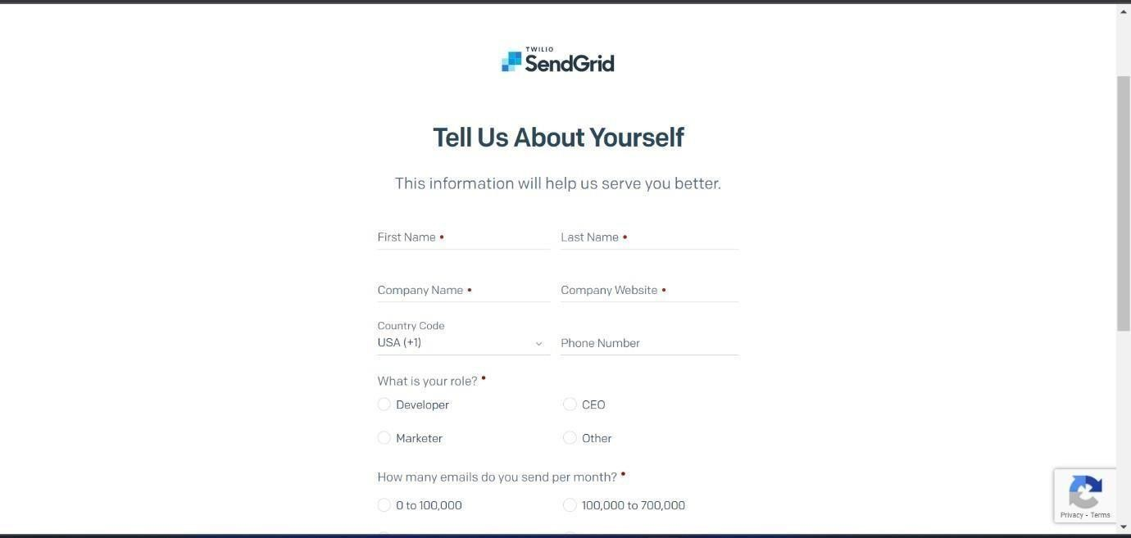

# Step 3:

Then it will redirect you to a home page of your sendgrid account.

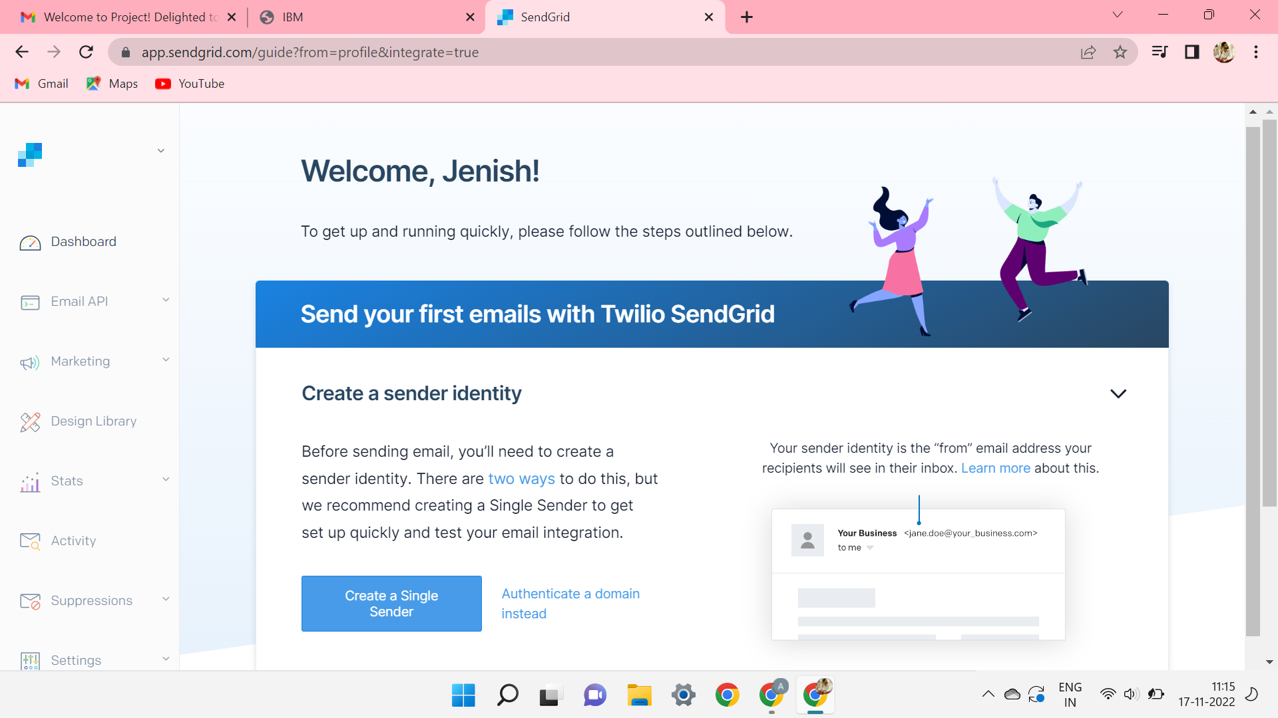

# Step 4:

Finally, you have created your account and now you can access the sendgrid account.